**PROJECT REPORT**

**ADVANCED CRIME CLASSIFICATION WITH DEEP LEARNING**

**1. INTRODUCTION**

**1.1 Project Overview:**

The objective of this project is to develop an advanced crime classification system using deep learning techniques. The system will analyze various types of crime data, such as text descriptions, images, or audio recordings, and classify them into different crime categories. By leveraging the power of deep learning, the project aims to improve the accuracy and efficiency of crime classification, aiding law enforcement agencies in their investigations and crime prevention efforts.

Crime identification using deep learning is a technique that involves applying deep learning techniques, specifically deep learning, to analyze images and video footage of crime scenes or incidents and identify and classify different types of crimes. Deep learning involves training neural networks on large amounts of data to recognize patterns and make predictions or decisions. By using deep learning, it is possible to analyze images and video footage of crime scenes or incidents and classify different types of crimes based on the type of activity depicted in the images. This can be useful in a variety of criminal justice and law enforcement contexts, including crime scene investigation, forensic analysis, and surveillance.

The expected outcomes of the project include:

* An advanced crime classification system capable of accurately classifying different types of crimes based on input data such as text, images, or audio.
* Improved efficiency and effectiveness in crime investigation and prevention by automating the crime classification process.
* Enhanced decision-making capabilities for law enforcement agencies through accurate categorization and analysis of crime data.
* A scalable and user-friendly system that can be integrated into existing law enforcement workflows and systems.

**1.2 Purpose:**

The purpose of advanced crime vision with deep learning is to leverage the power of artificial intelligence (AI) and deep learning techniques to enhance the capabilities of crime prevention, detection, and investigation systems. By utilizing advanced computer vision algorithms and neural networks, these systems can analyze and interpret visual data, enabling more efficient and effective crime-fighting strategies. Here are some key purposes of advanced crime vision with deep learning:

1. Crime Detection and Prevention: Deep learning models can be trained on vast amounts of surveillance footage to automatically identify and classify criminal activities. By analyzing video streams in real-time, these systems can detect suspicious behavior, identify potential threats, and trigger immediate alerts to law enforcement personnel. This helps in preventing crimes or responding swiftly to ongoing incidents.
2. Video Analysis and Understanding: Deep learning algorithms excel at extracting meaningful information from complex visual data. Advanced crime vision systems can analyze video feeds and extract valuable insights such as identifying individuals, tracking their movements, recognizing objects, and understanding the context of a scene. This enables law enforcement agencies to gain a deeper understanding of criminal activities and make informed decisions based on the analyzed data.
3. Predictive Analytics: Deep learning models can be trained on historical crime data, combined with various contextual factors, to generate predictive analytics models. These models can identify crime hotspots, patterns, and trends, enabling law enforcement agencies to allocate resources more efficiently and proactively address potential criminal activities. Predictive analytics can also aid in identifying individuals who may be at a higher risk of becoming involved in criminal behavior.
4. Enhanced Public Safety: By integrating with existing surveillance systems, advanced crime vision with deep learning can enhance public safety and security. These systems can monitor public spaces, transportation hubs, critical infrastructure, and other high-risk areas. They can detect and respond to incidents in real-time, assist in crowd management, and provide valuable situational awareness to law enforcement personnel.
5. Collaborative Investigation: Advanced crime vision systems can enable the sharing and analysis of visual data across different agencies and jurisdictions. This facilitates collaboration between law enforcement entities, allowing them to pool resources, share information, and coordinate efforts more effectively. This collaborative approach can improve the overall efficiency and effectiveness of investigations and crime prevention strategies.

In summary, advanced crime vision with deep learning aims to leverage AI technologies to enhance crime detection, prevention, investigation, and public safety. By automating visual data analysis, these systems empower law enforcement agencies with powerful tools for proactive crime-fighting and more efficient resource allocation.

**2. IDEATION AND PROPOSED SOLUTION**

**2.2 Problem Statement Definition:**

Traditional crime classification systems rely on manual data entry and categorization, which can be time-consuming, error-prone, and subjective. How can we automate the crime classification process using deep learning techniques, such as convolutional neural networks (CNNs) and recurrent neural networks (RNNs), to analyse crime-related data such as CCTV footage, police reports, and witness statements, and accurately classify crimes based on their characteristics?

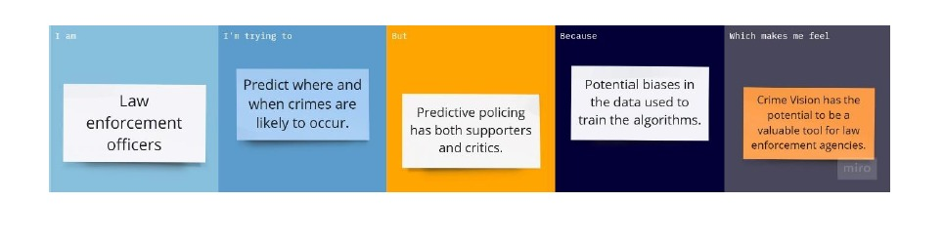

Many crime classification systems today are constrained by their lack of flexibility and adaptability to changing crime patterns and trends. How can we use deep learning algorithms to continuously learn and evolve based on new data and feedback, and improve the accuracy and relevance of crime classification over time?



**2.2 Empathy Map Canvas**

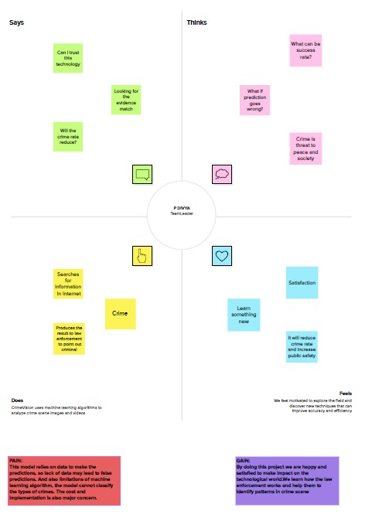

**2.3 Ideation and Brainstroming**

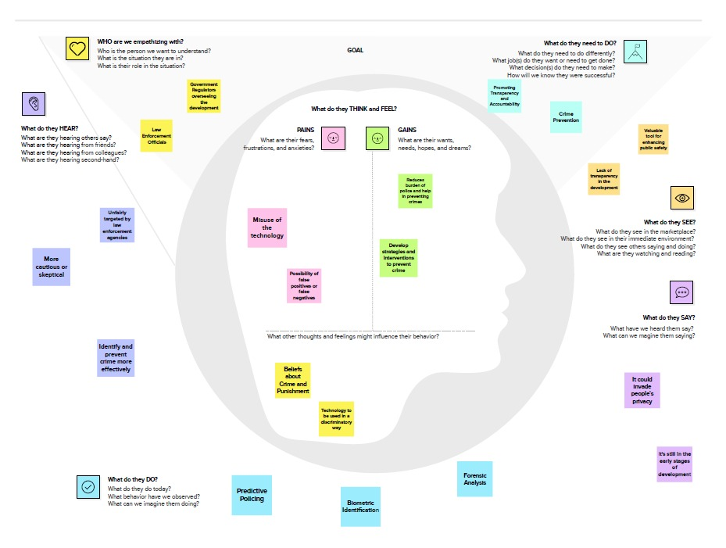

**2.4 Proposed Solution**

|  |  |  |
| --- | --- | --- |
| **S.no.** | **Parameter** | **Description** |
|  | Problem Statement (Problem to be solved) | Classification of a location for a crime hotspot and taking actions in controlling them accordingly. |
|  | Idea / Solution description | The proposed solution involves collecting and pre-processing crime data, training a machine learning model to classify locations as crime hotspots, deploying the model as an API, developing a user-friendly application to display hotspot locations, and continuously updating the model based on feedback and performance evaluation. |
|  | Novelty / Uniqueness | The solution also involves developing a user-friendly application that integrates with geolocation APIs to display hotspot locations and provide alerts to users when they enter high-risk areas. It provides a comprehensive approach to identifying and controlling crime hotspots, making it unique and effective in promoting safety and security in communities. |
|  | Social Impact / Customer Satisfaction | By providing accurate and up-to-date information on crime hotspots, individuals and law enforcement agencies can take necessary precautions and actions to prevent crime and reduce its impact on society. The solution can also help in identifying areas that require additional resources and attention to control crime. the solution can contribute to creating a safer and more secure environment for individuals, families, and communities. It can also help in building trust between citizens and law enforcement agencies by providing a transparent and collaborative approach to controlling crime hotspots. |
|  | Business Model (Revenue Model) | Freemium model: Offer a basic version of the application for free that displays crime hotspots in the area. Offer additional features such as customized alerts, crime prevention tips, and community safety forums for a subscription fee.  Subscription model: Charge a monthly or annual fee for access to the application's full features, including customized alerts, crime statistics, and safety tips.  Partner with local businesses: Partner with local businesses such as hotels, restaurants, and shopping centers to provide the application to their customers. Charge businesses a fee for providing the service and displaying their business information on the application.  Government contracts: Sell the solution as a service to government agencies, law enforcement departments, and other organizations responsible for public safety. Charge a fee for access to the data and the machine learning model API.  Advertising model: Display targeted ads within the application based on the user's location and demographics. Charge businesses for ad space within the application.  Overall, the business model for this application will depend on the target market, the application's features and capabilities, and the competitive landscape. By providing a valuable service that promotes safety and security, the application has the potential to generate revenue through a variety of business models. |
|  | Scalability of the Solution | Data Volume: As the application gathers more data, the machine learning model will need to be retrained and updated regularly to ensure accuracy and relevance. The infrastructure should be capable of handling large volumes of data and processing it efficiently.  Machine Learning Model: The machine learning model should be designed to scale with increasing data volume and complexity. This could involve using distributed computing or cloud-based platforms that can handle large volumes of data and provide scalable processing power.  Hardware Infrastructure: The application's hardware infrastructure should be designed to scale with the increasing number of users and data volume. This could involve using load balancers, distributed databases, and cloud-based infrastructure that can scale up or down depending on demand.  User Management: The application should have a robust user management system that can handle a large number of users. This could involve using identity and access management solutions, single sign-on (SSO), and multi-factor authentication (MFA) to ensure security and scalability.  Overall, the scalability of the solution will depend on careful planning and design of the application's architecture, data management, and machine learning models. By using scalable and cloud-based infrastructure, the application can easily handle increasing data volumes and user demand while ensuring high performance and reliability. |

**3.REQUIREMENT ANALYSIS**

**3.1 Functional Requirement**

Functional requirements for crime vision detection using deep learning could include:

1. Object Recognition: The system should be able to recognize various objects related to criminal activities, such as weapons, stolen items, or suspicious packages.

2. Facial Recognition: The system should have the capability to identify and match faces of known criminals or suspects from a database.

3. Activity Detection: The system should be able to detect and classify criminal activities or suspicious behavior, such as fighting, vandalism, or loitering.

4. Real-Time Monitoring: The system should provide real-time monitoring of the crime scene or specific areas, allowing for immediate response and intervention.

5. Alarm Generation: In the presence of a potential crime or threat, the system should be capable of generating alarms or alerts to notify relevant authorities or security personnel.

6. Video Analysis: The system should be able to analyze video footage to extract relevant information, such as timestamps, locations, and the sequence of events, to aid in investigations.

7. Integration with Surveillance Systems: The crime vision detection system should be compatible with existing surveillance infrastructure, enabling seamless integration with cameras, sensors, and other surveillance technologies.

8. Anomaly Detection: The system should be able to identify abnormal or unusual activities that may indicate potential criminal behavior, even if specific objects or faces are not recognized.

9. Scalability: The system should be designed to handle large volumes of video data from multiple cameras simultaneously, ensuring scalability to accommodate growing surveillance needs.

10. Accuracy and Reliability: The deep learning algorithms employed in the system should be accurate and reliable, with a low false-positive rate and high precision in detecting criminal activities.

11. User-Friendly Interface: The system should provide an intuitive and user-friendly interface for security personnel to interact with, allowing them to view live feeds, access recorded footage, and manage alarms effectively.

12. Privacy Considerations: The system should adhere to privacy regulations and ensure that personal data is protected, with appropriate access controls and encryption mechanisms in place.

13. Adaptive Learning: The system should be capable of continuously improving its performance through adaptive learning techniques, allowing it to adapt to new types of criminal activities or overcome challenges posed by changes in lighting, weather, or camera angles.

It is important to note that the specific functional requirements may vary depending on the scope and purpose of the crime vision detection system.

**3.2 Non-Functional Requirements**

Non-functional requirements for crime vision detection using deep learning could include:

1. Accuracy and Precision: The system should exhibit a high level of accuracy and precision in detecting and recognizing criminal activities, objects, and faces, minimizing false positives and false negatives.

2. Speed and Real-Time Processing: The system should be able to process and analyze video data in real time, providing timely detection and response to criminal activities.

3. Scalability: The system should be designed to handle increasing volumes of video data and be scalable to accommodate the addition of new surveillance cameras or expansion of the surveillance network.

4. Robustness and Reliability: The system should be able to handle various environmental conditions, lighting variations, camera angles, and occlusions, ensuring consistent performance and reliable results.

5. Adaptability and Generalization: The system should be able to adapt to new scenarios, changes in the environment, and evolving criminal tactics, demonstrating the ability to generalize and perform effectively in different contexts.

6. Privacy and Security: The system should prioritize the privacy of individuals and comply with privacy regulations, ensuring that personal data is protected, access controls are in place, and encryption mechanisms are employed.

7. Compatibility and Integration: The system should be compatible with existing surveillance infrastructure, allowing for seamless integration with cameras, storage systems, and other surveillance technologies.

8. Usability and User Experience: The system should provide an intuitive and user-friendly interface, facilitating ease of use for security personnel and operators, and minimizing the need for extensive training.

9. Maintenance and Support: The system should be designed for easy maintenance, with mechanisms for software updates, bug fixes, and technical support to ensure continuous operation and optimal performance.

10. Resource Efficiency: The system should utilize computational resources efficiently, optimizing processing power, memory usage, and energy consumption to minimize operational costs and environmental impact.

11. Ethical Considerations: The system should adhere to ethical guidelines and principles, ensuring fairness, transparency, and accountability in its operation, as well as avoiding biases and discrimination.

12. Interoperability: The system should be able to interact and share data with other security systems and law enforcement tools, enabling effective collaboration and information exchange.

13. Documentation and Reporting: The system should provide comprehensive documentation and reporting capabilities, allowing for the generation of detailed logs, statistics, and incident reports for investigative purposes.

These non-functional requirements are crucial in ensuring the effectiveness, reliability, and ethical considerations of a crime vision detection system based on deep learning.

**4. PROJECT DESIGN**

**4.1 Data Flow Diagram**

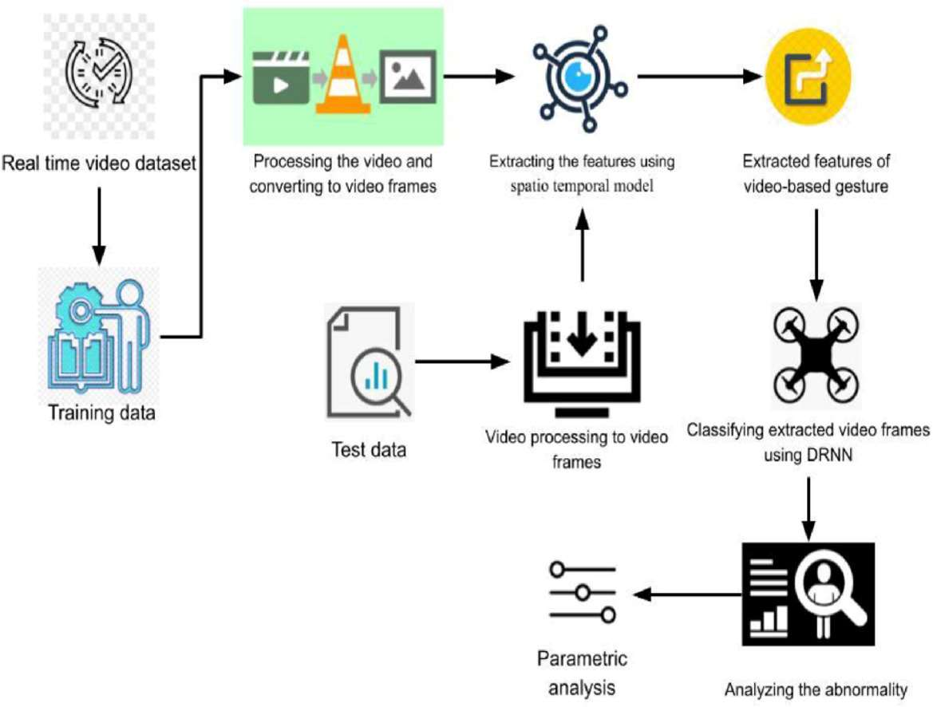

**4.2 Solution And Technical Architecture**

Crime Vision, a deep learning-based crime detection and prevention system, utilizes advanced computer vision techniques and deep learning algorithms to analyze video data and detect potential criminal activities. Here is an overview of the solution and its technical architecture:

1.Data Collection:

The system collects video data from various sources, such as surveillance cameras, body-worn cameras, or even personal devices like smartphones. This data serves as the input for the deep learning algorithms.

2.Preprocessing:

Before feeding the video data into the deep learning models, preprocessing steps are applied to enhance the quality and suitability of the data. This may include tasks like resizing, normalization, noise reduction, and frame extraction to ensure efficient processing.

3.Deep Learning Models:

Crime Vision employs various deep learning models to analyze the video data and extract meaningful features. Some common models used in crime detection include Convolutional Neural Networks (CNNs), Recurrent Neural Networks (RNNs), and Long Short-Term Memory (LSTM) networks. These models are trained on large datasets containing labeled examples of criminal activities.

4.Training and Optimization:

The deep learning models undergo a training phase where they learn to recognize patterns and features associated with criminal activities. This involves presenting the models with labeled training data and optimizing their parameters using techniques like backpropagation and gradient descent. The models are fine-tuned to improve their accuracy and minimize false positives.

5.Crime Detection and Classification:

Once the models are trained, they are deployed in the production environment for real-time crime detection. The video data is fed into the models, which analyze the frames or video streams and identify suspicious or criminal activities. The system can detect various types of crimes, including theft, assault, vandalism, loitering, or even abnormal behavior patterns.

6.Deployment and Scalability: The technical architecture should be designed for deployment on suitable hardware infrastructure, such as GPUs or dedicated deep learning servers, to handle the computational demands of real-time video analysis. The system should also be scalable to accommodate additional cameras or expanding surveillance networks.

7.Training and Model Updates: The deep learning models used in the system require periodic training and updates to maintain their accuracy and effectiveness. This involves collecting labeled datasets, retraining the models, and deploying new versions to the production environment.

8.Security and Privacy Considerations: The technical architecture should incorporate security measures, such as encryption of data in transit and at rest, access controls, and secure APIs for integration. Privacy considerations should be addressed by anonymizing or encrypting sensitive data and adhering to relevant privacy regulations.

**4.3 User Stories**

1. Sarah, a police officer:

Sarah, a dedicated police officer, utilizes Crime Vision to enhance her crime-fighting capabilities. While patrolling the city streets, she captures real-time video footage using her body-worn camera. Crime Vision, powered by deep learning algorithms, analyzes the video stream in real-time. It detects and alerts her to potential criminal activities such as theft, assault, or vandalism. This allows Sarah to respond swiftly and prevent crimes from escalating, improving public safety in her community.

2. James, a security guard:

James works as a security guard at a busy shopping mall. Equipped with multiple surveillance cameras, the mall utilizes Crime Vision to monitor the premises. James receives real-time alerts on his mobile device whenever the system detects suspicious behavior, like someone loitering near an exit or acting erratically. With this information, James can quickly investigate and take necessary actions to prevent potential thefts, ensuring a secure shopping environment for visitors.

3.Lisa, a concerned parent:

Lisa wants to ensure her child's safety while they walk home from school. She uses a personal safety app integrated with Crime Vision's deep learning capabilities. As her child walks, the app utilizes the smartphone camera to capture the surroundings and analyzes the video feed using Crime Vision. If the system detects any potential danger, such as a suspicious vehicle following the child, it immediately sends an alert to Lisa, allowing her to intervene or contact authorities promptly.

4.Mark, a city planner:

Mark works for the city's planning department and is responsible for enhancing public safety infrastructure. He leverages Crime Vision to analyze crime patterns within the city. By inputting historical crime data, the system uses deep learning algorithms to identify high-crime areas and predict potential hotspots. With this information, Mark can make data-driven decisions about where to allocate resources, such as increasing police patrols or implementing better lighting and surveillance systems, to effectively prevent crime and enhance overall community safety.

These user stories illustrate how individuals in different roles can utilize Crime Vision, empowered by deep learning, to proactively detect and prevent crime, improve public safety, and enhance law enforcement efforts.

**5. CODING AND POSITIONING**

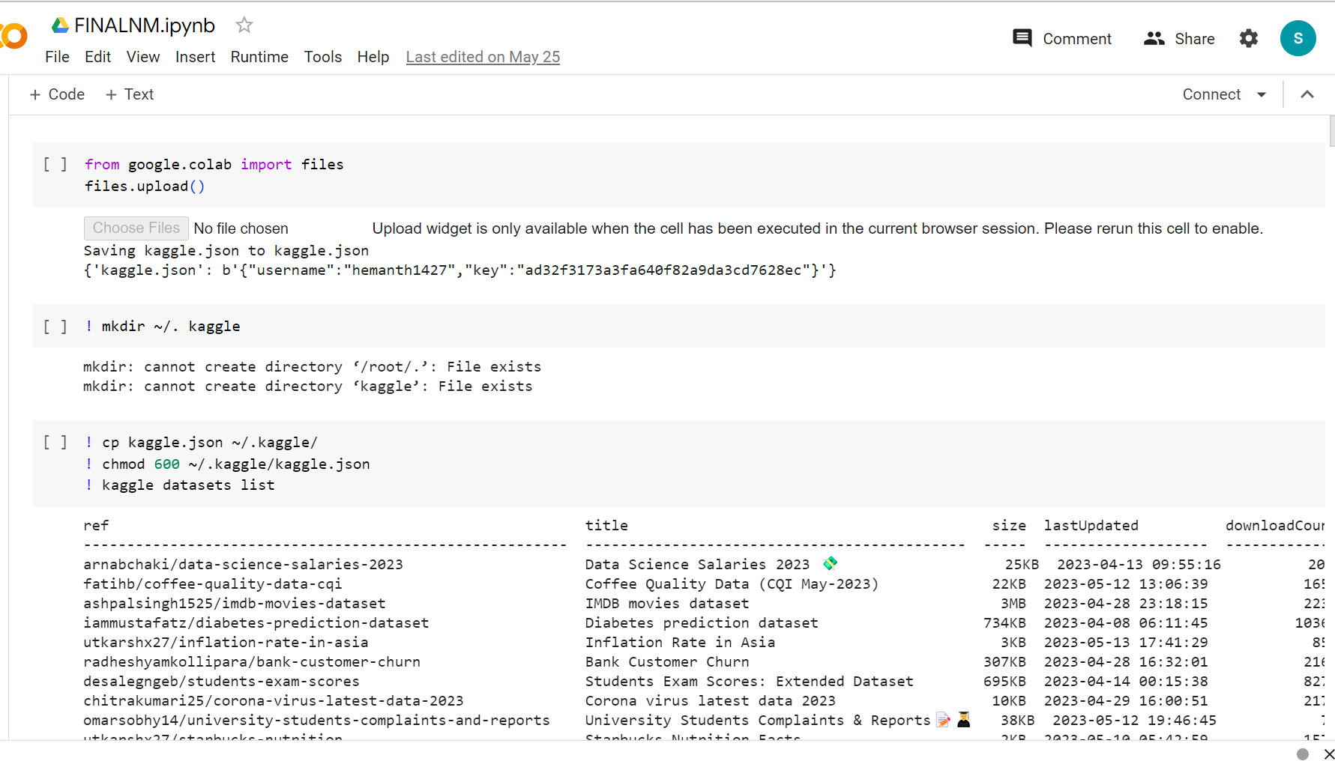







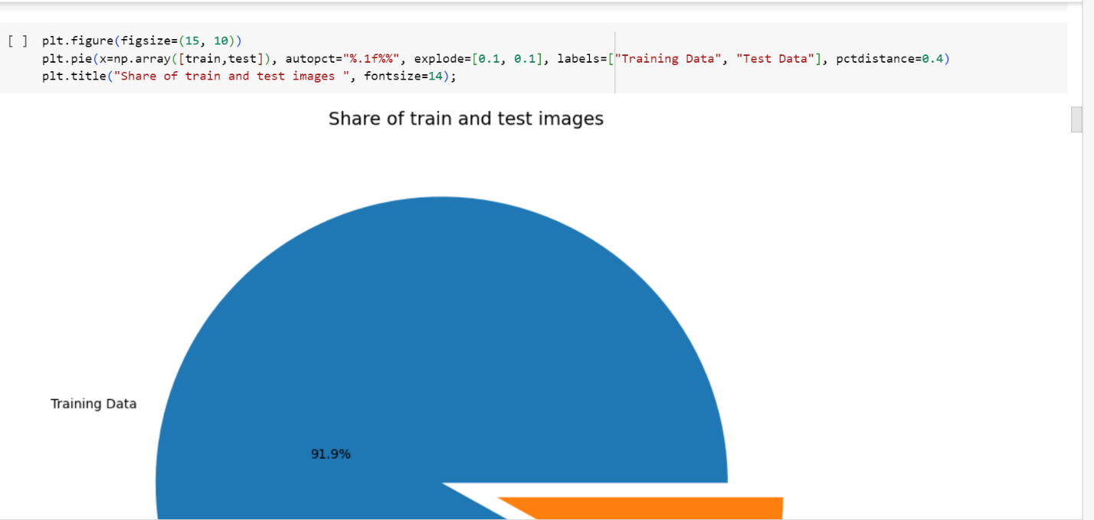

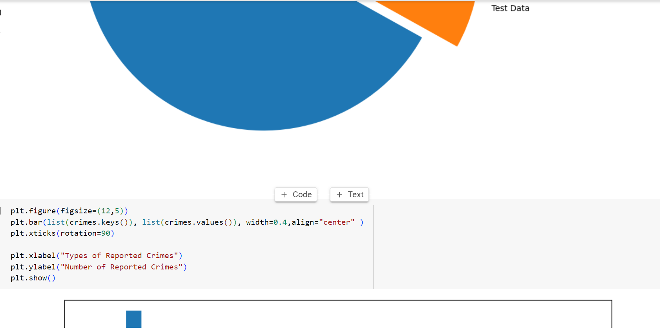

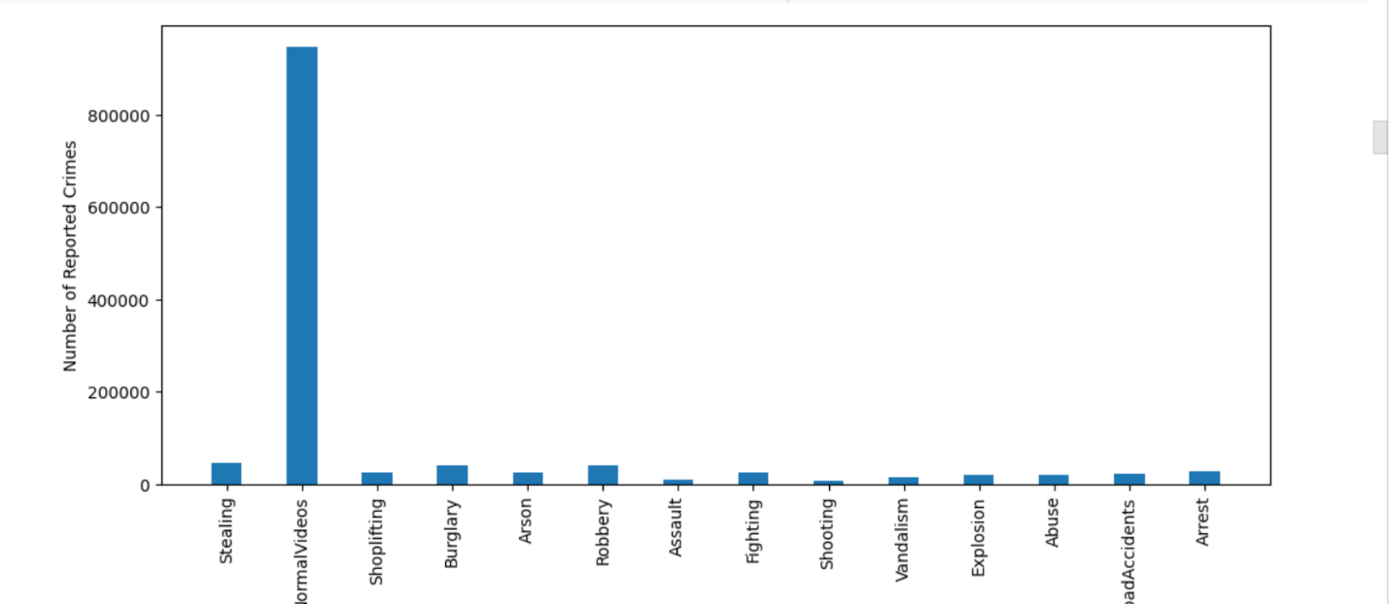

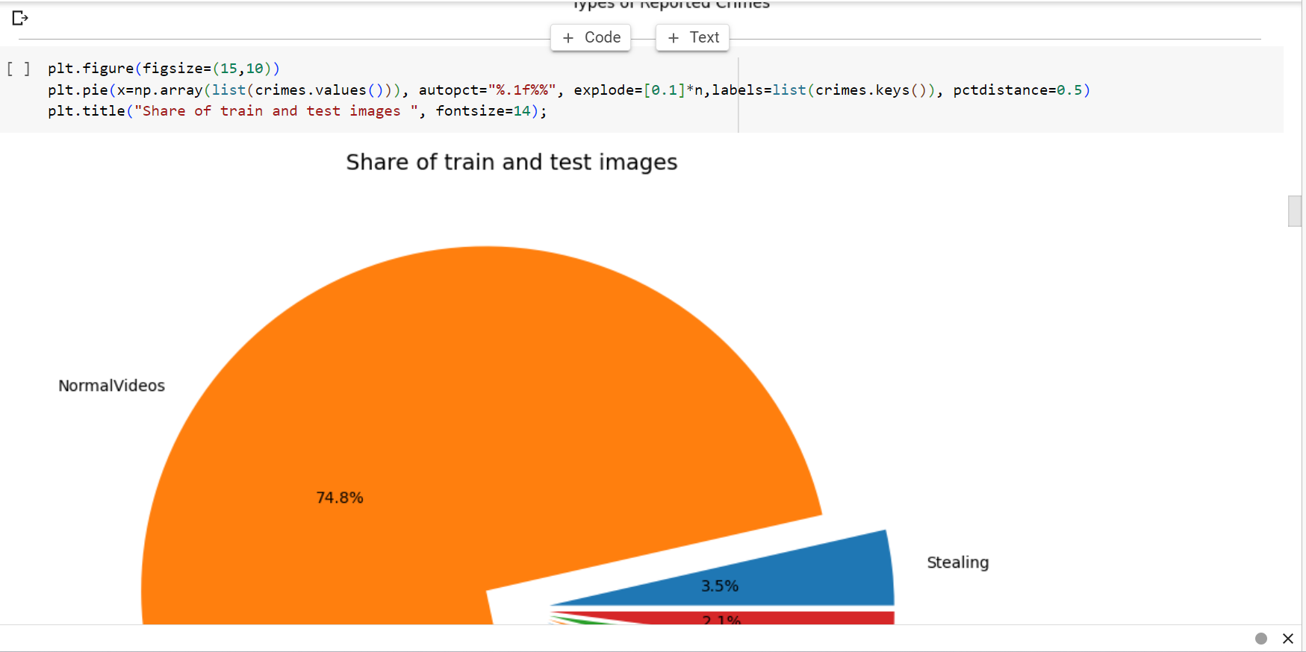

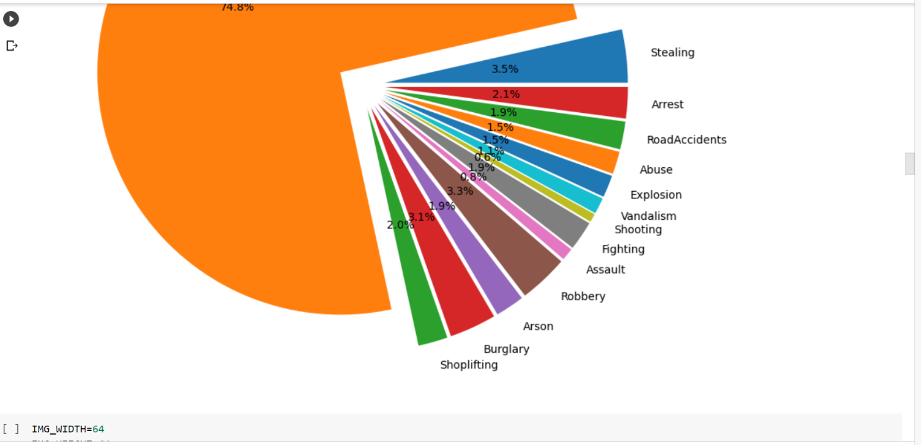



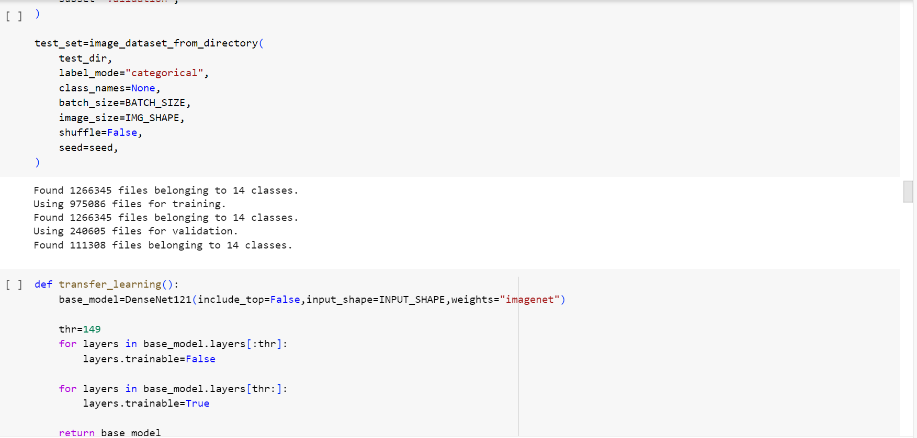





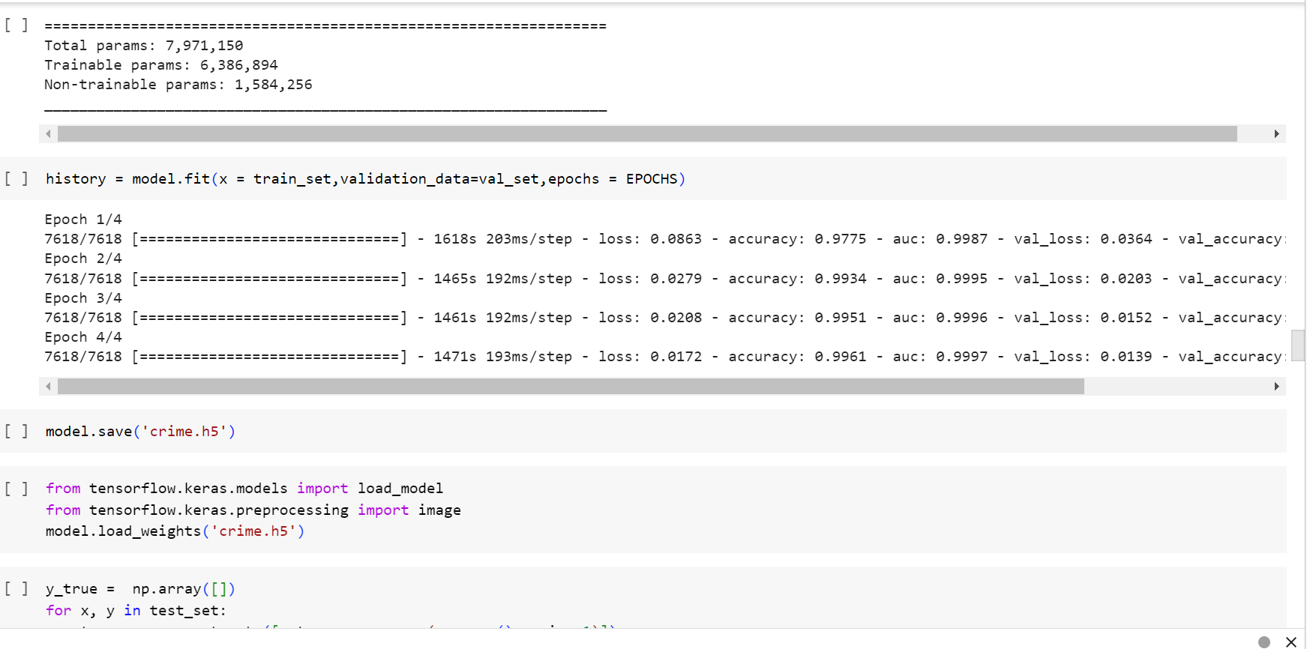

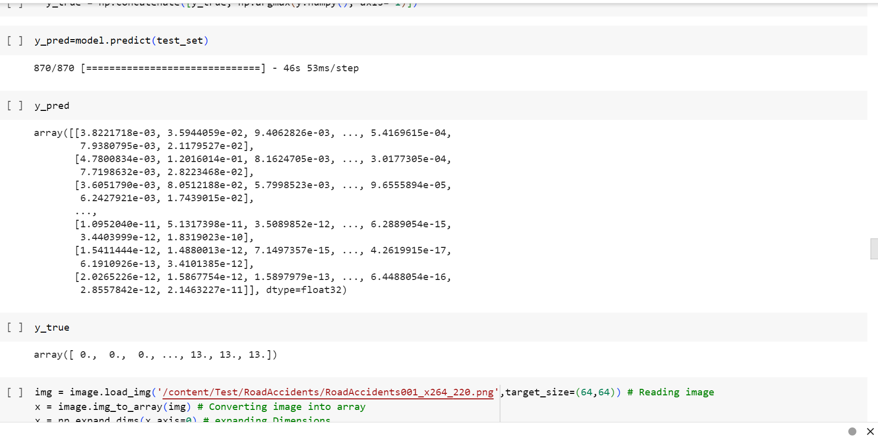

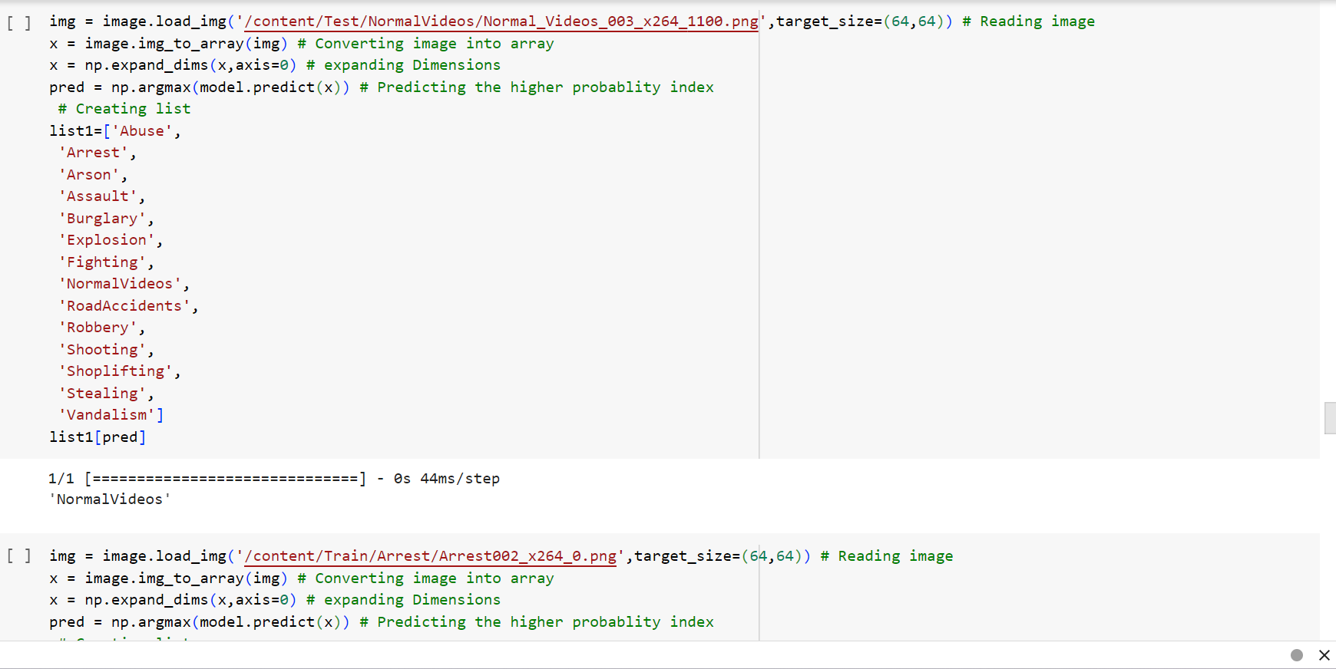

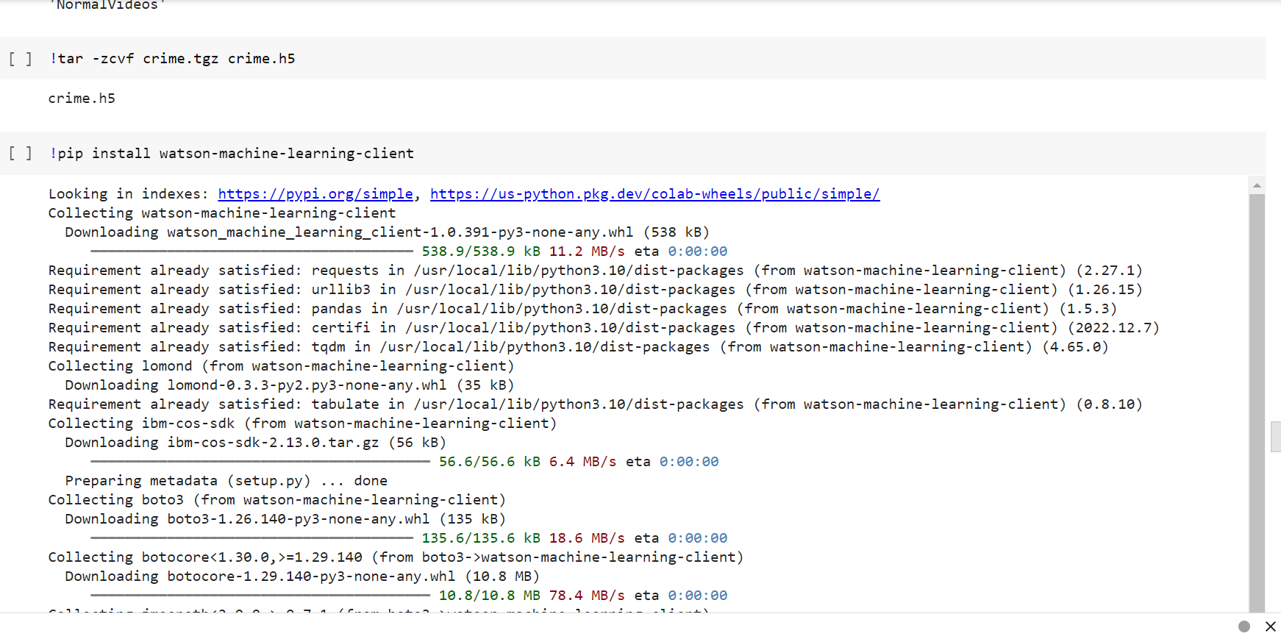

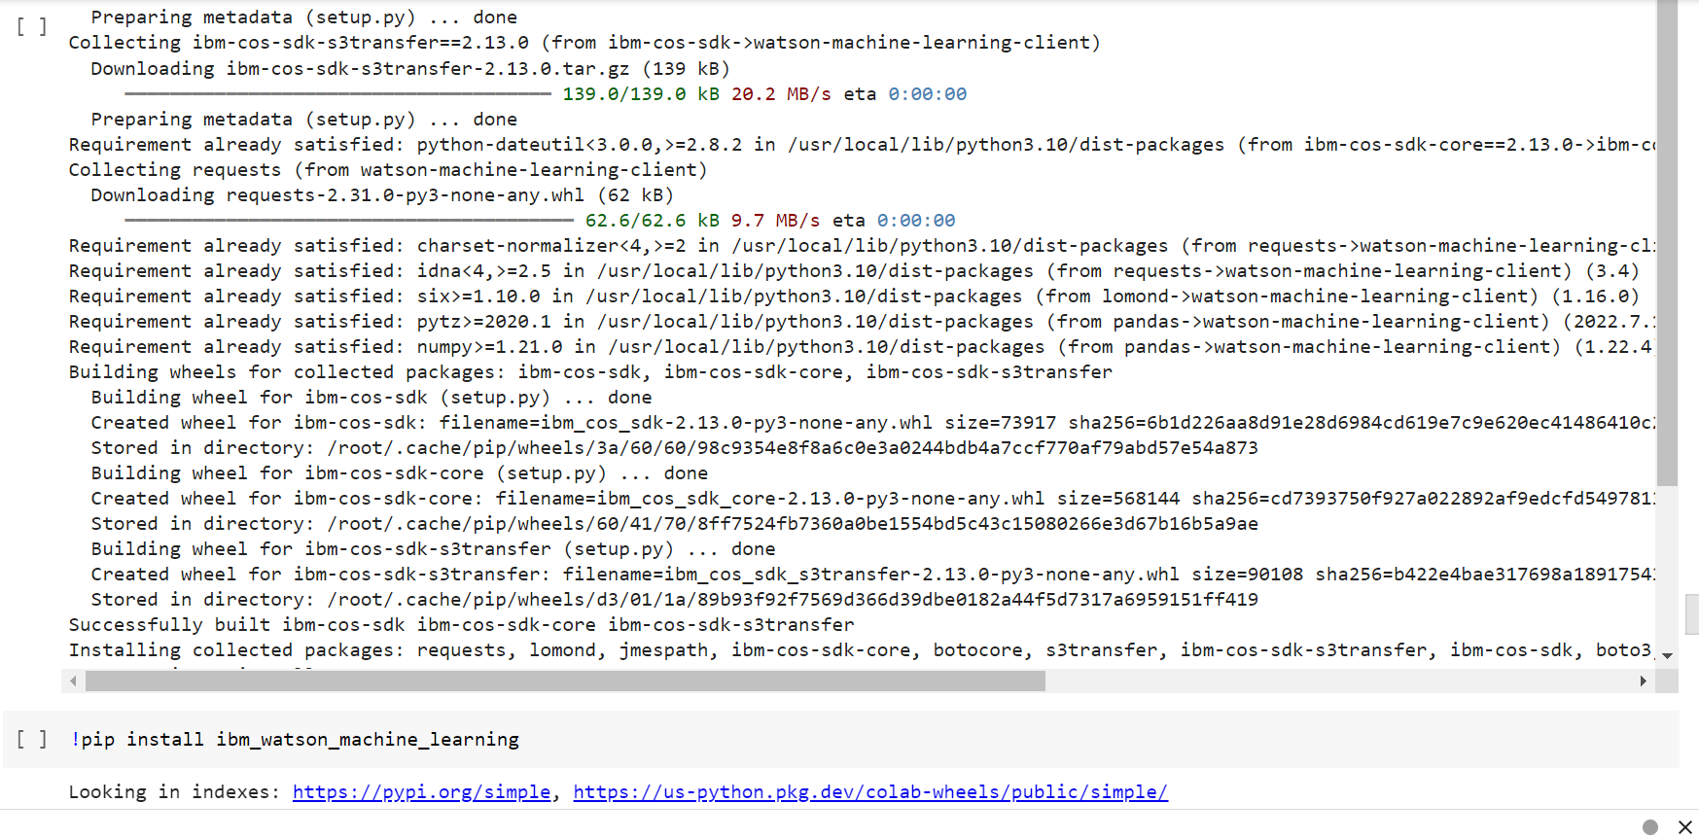



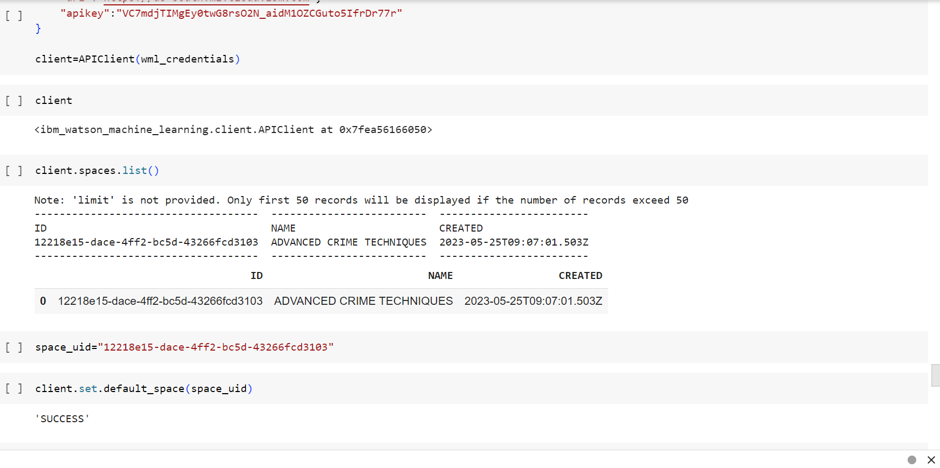

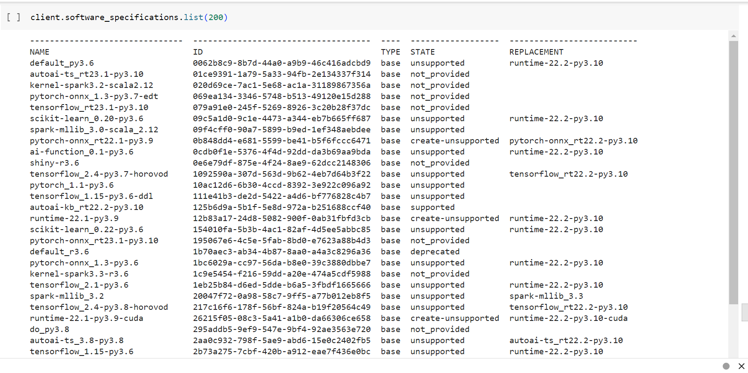











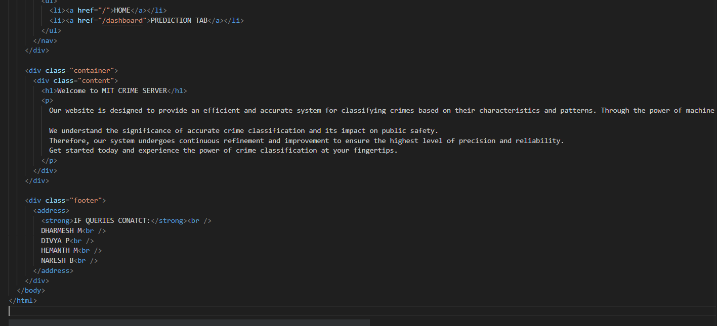

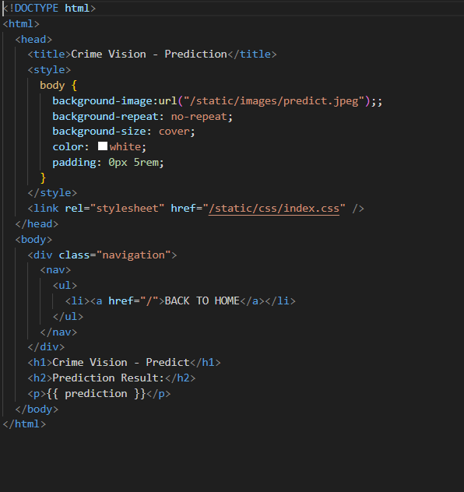









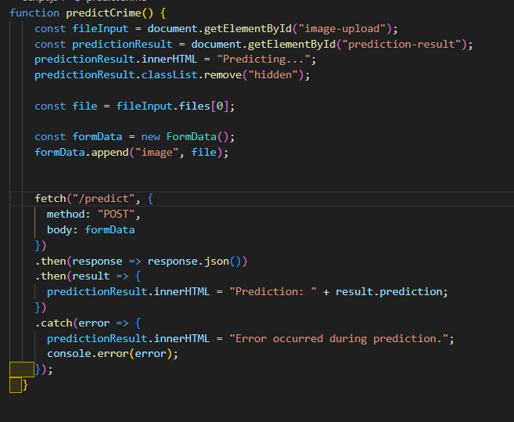

**6. RESULTS**







**7. ADVANTAGES AND DISADVANTAGES**

Advantages of Crime Vision with Deep Learning:

1. High Accuracy: Deep learning models have demonstrated impressive accuracy in object detection, facial recognition, and activity recognition tasks, making them highly effective for crime vision applications.

2. Real-time Monitoring: Crime vision systems using deep learning can analyze video data in real-time, enabling immediate detection of criminal activities and timely response by security personnel.

3. Automation and Efficiency: Deep learning models can automate the process of analyzing large volumes of video data, significantly reducing the manual effort required for surveillance and improving operational efficiency.

4. Scalability: Deep learning models can be scaled to handle large-scale surveillance systems with numerous cameras, allowing for expanded coverage and increased crime detection capabilities.

5. Adaptability and Generalization: Deep learning models can adapt and generalize well to various scenarios, making them capable of detecting new types of criminal activities or adapting to changes in the environment, lighting conditions, or camera angles.

6. Continuous Improvement: Deep learning models can be continuously trained and updated with new data, enabling the system to improve its accuracy and performance over time.

Disadvantages of Crime Vision with Deep Learning:

1. Data Requirements: Deep learning models typically require large amounts of labeled training data to achieve high accuracy. Obtaining and annotating such datasets can be time-consuming and expensive, especially for rare or unique criminal activities.

2. Hardware and Computational Resources: Deep learning models often require significant computational resources, such as powerful GPUs or specialized hardware accelerators, to process and analyze video data in real-time. This can increase the infrastructure and operational costs of implementing a crime vision system.

3. Lack of Interpretability: Deep learning models are often considered black boxes, meaning they provide accurate predictions but lack interpretability or explanations for their decisions. This can pose challenges in legal contexts where explainability is required for evidence or decision-making.

4. False Positives and False Negatives: Deep learning models may occasionally produce false positives (identifying an object or activity incorrectly) or false negatives (failing to detect a relevant object or activity). Balancing the trade-off between these errors can be challenging and require careful fine-tuning.

5. Ethical and Privacy Considerations: Crime vision systems using deep learning raise ethical concerns related to privacy, data security, and potential biases in the models. The system must ensure proper handling of personal information and address potential biases or discriminatory outcomes.

6. Maintenance and Updates: Deep learning models require regular updates and maintenance to keep up with evolving criminal tactics, new object classes, or changing environmental conditions. This can involve retraining the models, acquiring new labeled datasets, and deploying updated versions of the system.

It's important to consider these advantages and disadvantages when designing and implementing a crime vision system using deep learning. The specific context, requirements, and resources available should be taken into account to address potential limitations and ensure an effective and ethical implementation.

**8. CONCLUSION**

In conclusion, crime vision with deep learning offers significant potential for enhancing the detection and prevention of criminal activities. By leveraging advanced deep learning algorithms, such as object detection, facial recognition, and activity recognition, crime vision systems can analyze video data in real-time and provide accurate insights to security personnel. This technology enables high accuracy, automation, and scalability, making it an effective tool for surveillance and crime prevention.

However, there are also challenges and considerations to address. Deep learning models require large labeled datasets and computational resources, and ensuring privacy, interpretability, and ethical use of the technology is paramount. Ongoing research and advancements in deep learning techniques, hardware infrastructure, and integration with other technologies, such as IoT and edge computing, offer promising avenues for improvement.

Looking ahead, the future of crime vision with deep learning holds great potential. Advancements in model architectures, real-time analysis, multi-modal data integration, and unsupervised learning can further enhance the accuracy and efficiency of crime detection. Additionally, the development of explainable and transparent models, privacy-preserving solutions, and collaborative, distributed systems will be essential for widespread adoption.

With continued research, innovation, and responsible implementation, crime vision with deep learning can contribute to safer communities, improved security measures, and effective crime prevention strategies. The convergence of advanced technologies and ethical considerations will shape the future of crime vision, enabling a more secure and resilient society.

**9. FUTURE SCOPE**

The future scope of crime vision with deep learning is promising and opens up several possibilities for advancements and enhancements in the field. Here are some potential areas of future development:

1. Improved Accuracy and Efficiency: As deep learning algorithms continue to evolve, there is a scope for further improving the accuracy and efficiency of crime vision systems. Advancements in model architectures, training techniques, and data augmentation methods can lead to better performance in object detection, facial recognition, and activity recognition tasks.

2. Enhanced Real-time Analysis: Real-time analysis is crucial for timely response to criminal activities. Future advancements may focus on optimizing deep learning models and hardware infrastructure to enable faster and more efficient processing of video data in real-time. This could involve leveraging hardware accelerators, distributed computing, or edge computing technologies.

3. Multi-Modal Data Integration: Integrating data from multiple sources, such as video, audio, and sensor data, can provide richer context for crime vision systems. Future developments may explore the fusion of multi-modal data using deep learning techniques, enabling more comprehensive and accurate detection and analysis of criminal activities.

4. Few-shot and Zero-shot Learning: Traditional deep learning approaches heavily rely on large labeled datasets for training. Future research may focus on exploring few-shot and zero-shot learning techniques, where models can learn to recognize new objects or activities with limited or no labeled training examples. This would enhance the adaptability and generalization capabilities of crime vision systems.

5. Explainable and Transparent Models: Deep learning models often lack interpretability, which can be a challenge in legal contexts or when explaining system decisions. Future advancements may involve developing techniques to make deep learning models more interpretable and transparent, providing explanations for their predictions and enabling better trust and accountability.

6. Autonomous Systems and Robotics: Integration of crime vision with autonomous systems and robotics can create advanced surveillance solutions. Future developments may involve the use of drones, autonomous vehicles, or mobile robots equipped with crime vision capabilities for enhanced situational awareness and response in complex environments.

These future developments in crime vision with deep learning hold great potential for improving the accuracy, efficiency, adaptability, and ethical considerations of crime detection and prevention systems. Continued research, technological advancements, and collaborations will play a vital role in shaping the future of crime vision with deep learning.

**10. APPENDIX**